



**Purpose & Vision**

***“Efforts and courage are not enough without purpose and direction.” John F. Kennedy***

**COMPLETED BY: ........................................................................**

**DATE: ...........................................................................................**

# The Find Your Happy Framework

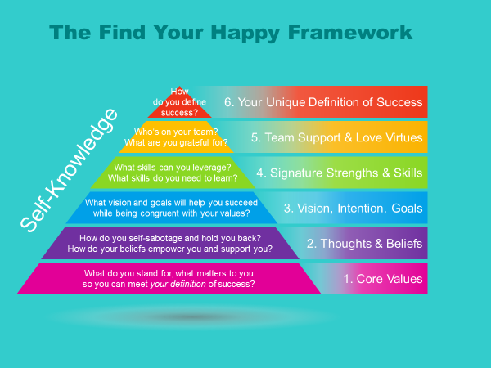

The Find Your Happy program will assist you to open up the way you think about yourself, the way you think about the world and set the stage for new beginnings and personal success.

# Purpose & Vision

You are the only one who can truly help you discover your unique purpose and vision. This is the discovery process I named Find Your Happy. Happiness is inside you waiting to be expressed by learning how to connect with yourself, ask some deep meaningful questions and by listening to your inner-voice and taking effective action.

So let’s begin this awesome adventure...what do you know about you?...What makes you happy?...What makes your heart sing?...What is your truest desire?... your truest deepest wish?

Use the tools and questions that follow to explore and discover what makes YOU happy, truly happy...not just entertainment happy ~~-~~ but truly happy at your core. What makes you come alive? Dare to dig deep and learn more about yourself.

Go somewhere quiet, with no internet or other disruptions and give yourself the gift of time to develop your answers. Some may apply more than others. That’s fine. Be honest with yourself. And don’t rush through these questions. These questions will only be useful if you allow them to.

*It’s time to find your happy...make it fun!*

In this section you will:

* Assess where you are now
* Explore where you want to be
* Dream BIG!

|  |  |
| --- | --- |
| Image result for starImage result for star | *Being busy does not always mean real work. The object of all work is production or accomplishment and to either of these ends there must be forethought, system, planning, intelligence, and honest purpose,  as well as perspiration.  Seeming to do is not doing.* ***Thomas A. Edison*** |

## Find your Purpose

“What is my purpose here? I know there’s something I’m supposed to be doing, but I don’t know how to find out what it is.” Our purpose is what makes life juicy. To discover your purpose, and follow up on it is an incredible way to live life.

Finding your calling, being healthy, and stress free go hand in hand. When you find why you’re truly here on this planet, you will inevitably become happier. Knowing who you are and what you want out of life can help you achieve more and be more. And it can help you make better, bigger decisions each day.

Living life with passion can be the difference between happiness and frustration. Do you know what you are passionate about? Is there anything in your life that makes you feel genuinely good, excited, alive, and turned on? If not, either you have not found your life passion or you are disregarding it. The problem is that many people have lost touch with their passion and purpose and don’t know how to access this information.

Many of us have come to believe we should be serious and responsible, and spend our time working hard at accomplishing goals. We feel worthy and virtuous when we attend to endless tasks and slave away at tasks we detest. We feel ashamed about spending time on things that make us feel alive and happy.

Doing what makes you happy is smart. Being pleased makes you healthier, more productive, and even nicer to be around.

How you are spending the treasured minutes and hours of your life? When was the last time you spent a couple of hours doing something that made you feel genuinely happy and alive?

## How to Find Your Purpose

People who are living a purposeful life with genuine passion are magnetic, they're charismatic and they're inspiring. These are the leaders of the world and the people who shape change.

Bringing passion back into your life is the secret to finding real happiness. Passion refers to anything that you feel super excited about and anything that makes you eager to get out of bed in the morning. As you find your passion and more time and ways to action it, you become happier. This makes the people around you happier too. Who would you rather see each day at breakfast, somebody bored and frustrated, or somebody filled with enthusiasm?

To discover your life’s purpose, I invite you to inquire within. It’s simple. The blueprint for this information lies within your core self, your essence. This is the vital, alive aspect of ourselves, the aspect of us that just wants to joyfully express ourselves in the world. As you allow this aspect to emerge, you will gradually discover what truly brings you joy.

Feel and sense at what desires, dreams, aspirations, hopes and longings and discontents you carry most closely in your heart. What are you longing for? What is your discontent right now?

If you could do anything in the world what would that be? The path to manifesting your unique gifts in the world begins from within and then expands outward, as you begin to take actions based on your heart's calling. Your true life's work is to listen, follow, share your gifts, and manifest all that you are in the physical world.

In our society, we tend to ignore our special talents and choose our careers according to what will give us a sense of security. Too often, however, what makes us feel safe may not necessarily fulfill us.

To begin the process of becoming aware of your purpose, allow yourself to quiet the mind. In a state of deep self-love and peaceful-ness, ask yourself, “What is my purpose for living?”

To help you connect with the part of yourself that holds the answers to your deepest questions, I recommend you listen to the 15 min. “Life Purpose Discovery” Guided Imagery recording. Click here:. <http://findyoursuperhappy.com/index.php/discover-your-purpose/>

Allow the answer to come to you. Let it be as expansive as you can imagine. The words you choose need not be flowery or poetic; what is important is how inspired the words make you feel. Also, the simpler your purpose, the more powerful it will be.

Some examples of individual purposes:

* My purpose is living with an open heart.
* My purpose is to feel and trust the power that I am.
* My purpose is radiating happiness.
* My purpose is loving myself unconditionally just the way I am.

Also, consider the following ideas for inspiration:

* Alleviate the suffering of others.
* Fearlessly try new things and visit new places.
* Make a living in the field of music.
* Be a supportive and loving parent.
* Be grateful for all the experiences that enter my life.
* Be a committed life-long learner.

|  |  |
| --- | --- |
| Image result for starImage result for star | *“To accomplish great things, we must not only act, but also dream; not only plan, but also believe.”*  [***Anatole France***](http://www.wisdomquotes.com/000376.html) |

## Discover your Vision

**Vision Discovery Visualization:**

This is a powerful technique that can help you manifest your vision. To help you visualize your dream listen to this 10 min. “Vision Discovery” imagery recording  
Click here:

## Know Where You Are

**Where in your life are you right now?** It’s tough to get to where you want to go unless you know where you are starting from. There is huge power in knowing who you are, what you want and why, this is what leads you to your passion. So take a quiet moment to enjoy composing your responses to these questions:

What do you enjoy doing the most? ……………………………………………………………………………..

……………………………………………………………………………………………………………………………………

Why do you enjoy these things? …………………………………..………………………………………………

……………………………………………………………………………………………………………………………………

What don’t you enjoy doing? ..………………………………………………………………………………………

……………………………………………………………………………………………………………………………………

Why don’t you enjoy these things? ………………………….……………………………………………………

……………………………………………………………………………………………………………………………………

What makes you happy? ……………………………………………..……………………………………………….

……………………………………………………………………………………………………………………………………

What makes you sad? ………………………………………………………………………………………………….

……………………………………………………………………………………………………………………………………

What is missing in your life? …………………….……………..……………………………………………………

……………………………………………………………………………………………………………………………………

……………………………………………………………………………………………………………………………………

What would make life more fulfilling? ……………………………………………………………………………

……………………………………………………………………………………………………………………………………

……………………………………………………………………………………………………………………………………

## Know What You Want to Be, Do or Have:

**What is your deepest desire?** Where do you want to be, do, or have??

Knowing where you are now, you can start defining where you want to be. The next step is to figure out what it is that you really want. So, ask yourself the following questions:

What motivates you…What makes your heart sing? ………………………………………………………..

……………………………………………………………………………………………………………………………………

What is your dream, your passion, your purpose? ……………………………………..……………………

……………………………………………………………………………………………………………………………………

What makes you happy, truly happy? ...............................................................................

……………………………………………………………………………………………………………………………………

If there was a secret passion in your life, what would it be? …………………………………………...

……………………………………………………………………………………………………………………………………

What does success mean, look like to you? …………………………………………………………………….

……………………………………………………………………………………………………………………………………

If there was something you were avoiding or running away from, what would that be?

……………………………………………………………………………………………………………………………………

……………………………………………………………………………………………………………………………………

What would you love to be, do, or have this year? …………………………………..…………………….

……………………………………………………………………………………………………………………………………

What would you love to be, do, or have in the next five years? ………….……………………………

……………………………………………………………………………………………………………………………………

What would you love to be, do, or have in your lifetime? …………..…………………………………...

……………………………………………………………………………………………………………………………………

*Someday, when I get time, I’m going to ……………..………………………………………………………..*

……………………………………………………………………………………………………………………………………

## Wheel of Life

Conduct your own Wheel of Life Assessment to get an overview of the balance that currently exists between each of the key areas in your life.

***The key areas considered include:***

1. Career/Business (what you do with your time to make money)
2. Finances and Wealth (managing your money)
3. Friends and Family (important platonic relationships)
4. Fun, Recreation and Entertainment (guiltless, earned pleasure)
5. Health and Fitness (exercise and nutrition)
6. Love Life (significant other)
7. Personal/Spiritual Development (things you want to develop just for you)
8. Physical Environment (your physical location – house, city, state, country)

**Instructions**

1. Rank your level of satisfaction within each area of your life by drawing a single point in each of the eight segments of the circle displayed on this page. When plotting your point consider that the center of the wheel *= 1 for POOR* and the outer edge *= 10 for EXCELLENT*.
2. Once you have ranked each segment, draw a line connecting each of the points. The new perimeter represents your Wheel of Life.

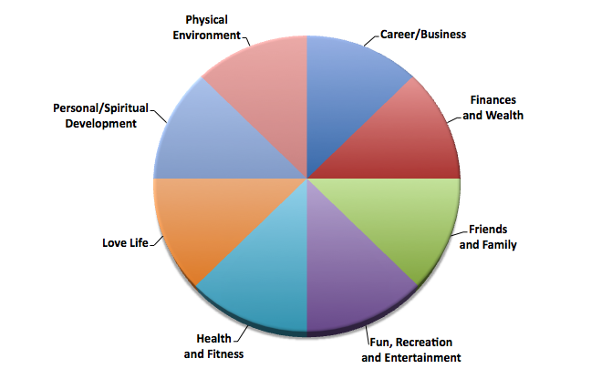

|  |
| --- |
| **🖉 *What do you think of your Wheel of Life? Is it a bumpy or a smooth ride?*** |
|  |
|  |
|  |
|  |
|  |
|  |
|  |
|  |

|  |
| --- |
| **🖉 *What can you do in each life area to make it better?*** |
| Career/Business |
| Finances and Wealth |
| Friends and Family |
| Fun, Recreation and Entertainment |
| Health and Fitness |
| Love Life |
| Personal/Spiritual Development |
| Physical Environment |

## Dream BIG!

**Where Do I Want to Be? -**

As you look at where you are on the wheel of life are you where you want to be? What would you like to see changing?

One thing I have learned from Tim Ferriss, author of *The 4-hour Workweek*, is that it can be helpful to explore what you may think of as unrealistic goals. What are the goals that you would love to do but just seem so crazy, exciting and different from your life right now that you don’t even think about them? What are you putting off until retirement?

Now, imagine you have the power to create anything just by simply wishing for it. And imagine you can have anything and everything your heart desires.

“What would a fulfilling and successful life, look and feel like in each area of my life if it was ranked as a perfect 10?”

1. Shake up your sleepy brain by exploring your wildest dreams.
2. Once they are all listed, ask yourself this: 'What is the worst that could possibly happen if I went for my dream?'
3. Next ask yourself: 'If the worst happened, what would I have to do to get back to my life as it is right now?'

|  |  |  |
| --- | --- | --- |
| **🖈** | ***EXAMPLE:***   * ***Crazy, exciting dream*** *– move to the Bahamas* * ***Worst-case scenario*** *– I move there and hate it and want to move back home.* * ***Contingency plan*** *– I’ll need to have back-up money in the bank before I move (enough to get me and my stuff back home).* |  |

|  |
| --- |
| ***🖉What are you putting off until retirement? What crazy, exciting dream would you   have in each area of your life if you knew you could not fail?*** |
| Career/Business |
| Finances and Wealth |
| Friends and Family |
| Fun, Recreation and Entertainment |
| Health and Fitness |
| Love Life |
| Personal/Spiritual Development |
| Physical Environment |

|  |
| --- |
| ***🖉 Answer the following questions for each of your crazy, exciting dreams.***   * What is the absolute worst that could happen if you went for your dream and it didn’t work out? * If the worst happened, what would you have to do to get back to your life as it is now? |
| Career/Business |
| Finances and Wealth |
| Friends and Family |
| Fun, Recreation and Entertainment |
| Health and Fitness |
| Love Life |
| Personal/Spiritual Development |
| Physical Environment |

## Your Life Vision

Now, that you know what it is that you want in every area of your life, it’s time to piece it together and create your Life Vision. Write in the space below in main bullet points your life imagined as a perfect 5.

*I am Happy and Grateful now that* ....................................................................................

.......................................................................................................................................

.......................................................................................................................................

.......................................................................................................................................

.......................................................................................................................................

.......................................................................................................................................

.......................................................................................................................................

.......................................................................................................................................

.......................................................................................................................................

.......................................................................................................................................

.......................................................................................................................................

.......................................................................................................................................

.......................................................................................................................................

.......................................................................................................................................

.......................................................................................................................................

.......................................................................................................................................

.......................................................................................................................................

*Awesome job…Well done!* ☺ You have created your new vision for your Life! Print a copy of your vision and keep it with you. Read it every day, morning and night and make sure to spend 10-15 minutes visualizing your dream life as though you’re living it right now.

You will be pleasantly surprised at the people, resources and opportunities that will be presented to you bringing you closer to “Find Your Happy!”

## Chase your Passion by Following your Dream.

Now that you know your life’s purpose and you have a blueprint of your vision, what is (*at the very least)* one thing you will do differently from this moment forward?

.......................................................................................................................................

.......................................................................................................................................

.......................................................................................................................................

.......................................................................................................................................

.......................................................................................................................................