



**Goals**

**Set & Achieve Goals**

***“Goals are dreams with deadlines.” ― Diana Scharf***

**COMPLETED BY: ........................................................................**

**DATE: ...........................................................................................**

# The Find Your Happy Framework

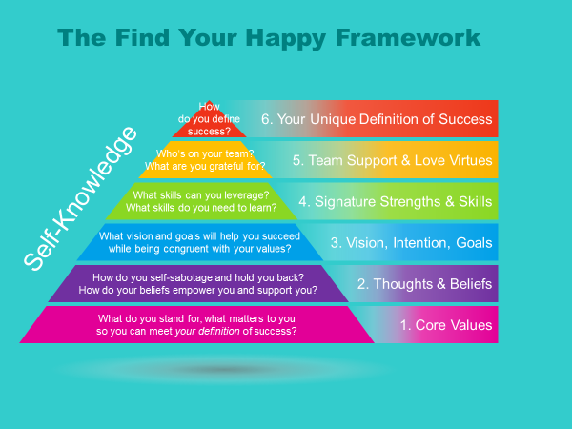

The Find Your Happy program will assist you to open up the way you think about yourself, the way you think about the world and set the stage for new beginnings and personal success.

## Goals Come in All Shapes and Sizes

Imagine yourself a year from now. What do you see? Are things about the same in your life as it is today?

If it hasn't changed, to be absolutely honest with you, it's because of you. You didn't put the things in place to make it change. But you already know that, don't you?

In the last module your assignment was to take the time to really search your thoughts and feelings to figure out what your ideal life would be. In this module we're exploring your best vision for your life and the goals that will determine your success in achieving that vision.

Please don't put down what you "think" you should want or what someone else might want for you. If you do, you'll end up being successful at living someone else's life. That's not what you want, right? I thought so.

What is the best version of yourself that you can possibly imagine? Some people are a little shy or don’t feel quite comfortable to say out loud or even think to themselves about their dreams. I ask that you don’t. It is your birthright to dream your dreams. It is why you're here. This is your chance to grab the best life you can imagine. And it starts here and now. I suggest that you give plenty of time and attention to this module. It might be the most important module of all in this program.

Goals come in different shapes and sizes and have different levels of importance.

* Big goals are the goals that you must have to live a full and rich life. When you get to the next stage of the program, the Happy Goal Tracker, your big goals will help you write vision statements for each area of your life.
* Medium goals are the steps that need to happen before your big goals can be realized. These are likely to become your six-month goals when you get to the Happy Goal Tracker phase of the program.
* Small goals are the tasks that tend to take up most of your time and energy. Eventually all of your small goals should become tasks you do each week that move you closer to achieving your six-month goals and ultimately your vision statements.

|  |  |
| --- | --- |
| **🛠** | ***The Aim of the Game***  Once you know your goals, assess how much of your time goes towards realizing your goals and how much time does not.  Any time you spend on activities that are not moving you forward towards achieving your goals is either wasted time OR an indicator that you have left something important out of your goals. |

|  |  |
| --- | --- |
| Image result for starImage result for star | *“There is nothing so useless as doing efficiently that which should not be done at all.”* [***Peter F. Drucker***](http://www.wisdomquotes.com/003096.html) |

|  |  |  |  |
| --- | --- | --- | --- |
| **🖈** | ***EXAMPLE:***   1. ***Big goal*** *– your Vision Statement – the main prize*    * *Live in a beautiful and comfortable home by the sea in a community that shares my core values.* 2. ***Medium goals*** *– six-month goals – steps that help me get to the main prize*    * *Decide on a few locations/countries that I like*    * *Visit each location on my list*    * *Choose the one I want to move to and a moving date*    * *Make the move*    * *Etc.* 3. ***Small goals*** *– daily/weekly tasks that help me complete my medium goals*    * *Research seaside communities on the internet*    * *Get a passport*    * *Purchase flights*    * *Develop a checklist to help me assess each location*    * *Pack boxes*    * *Etc.* | |  |
| **🛠** | | ***Spend Your Time Wisely***  *Make sure you spend time each week on activities that move you towards your goals.* | |

List 10 goals (big, medium and small) that you can imagine for each area of your life. (Yes, 10 goals for each area – we want to get you thinking outside the box!)

| **🖉 *Exploring goals*** |
| --- |
| Career/Business |
| 1 |
| 2 |
| 3 |
| 4 |
| 5 |
| 6 |
| 7 |
| 8 |
| 9 |
| 10 |
| Finances and Wealth |
| 1 |
| 2 |
| 3 |
| 4 |
| 5 |
| 6 |
| 7 |
| 8 |
| 9 |
| 10 |
| Friends and Family |
| 1 |
| 2 |
| 3 |
| 4 |
| 5 |
| 6 |
| 7 |
| 8 |
| 9 |
| 10 |
| Fun, Recreation and Entertainment |
| 1 |
| 2 |
| 3 |
| 4 |
| 5 |
| 6 |
| 7 |
| 8 |
| 9 |
| 10 |
| Health and Fitness |
| 1 |
| 2 |
| 3 |
| 4 |
| 5 |
| 6 |
| 7 |
| 8 |
| 9 |
| 10 |
| Love Life |
| 1 |
| 2 |
| 3 |
| 4 |
| 5 |
| 6 |
| 7 |
| 8 |
| 9 |
| 10 |
| Personal/Spiritual Development |
| 1 |
| 2 |
| 3 |
| 4 |
| 5 |
| 6 |
| 7 |
| 8 |
| 9 |
| 10 |
| Physical Environment |
| 1 |
| 2 |
| 3 |
| 4 |
| 5 |
| 6 |
| 7 |
| 8 |
| 9 |
| 10 |

|  |  |
| --- | --- |
| **🛠** | ***Color-Code Your Goals***   1. *Highlight all of your big goals in one color.* 2. *Highlight all of your medium goals in another color.* 3. *Highlight all of your small goals in a third color.* |

|  |
| --- |
| **🖉 *What activities currently take up most of your time?*** |
|  |
|  |
|  |
|  |
|  |
|  |
|  |
|  |
|  |
|  |

|  |
| --- |
| **🖉 *How much of your time is currently spent working towards your goals?*** |
|  |
|  |
|  |
|  |
|  |
|  |
|  |

|  |
| --- |
| **🖉 *How much of your time would you like to spend working towards your goals?*** |
|  |
|  |
|  |
|  |
|  |
|  |
|  |

|  |
| --- |
| **🖉 *Do you need to make any changes to the way you spend your time?   If yes, what specifically will you change?*** |
|  |
|  |
|  |
|  |
|  |
|  |
|  |
|  |
|  |
|  |

## Expand Your Comfort Zone

We all have our own comfort zone, or space that we know. When we are ready to try something new, chances are good that this new thing will lie outside of our comfort zone. If it happens to be something that is close to our comfort zone it will be easier to achieve, and if it is way outside our comfort zone it could be more of a challenge.

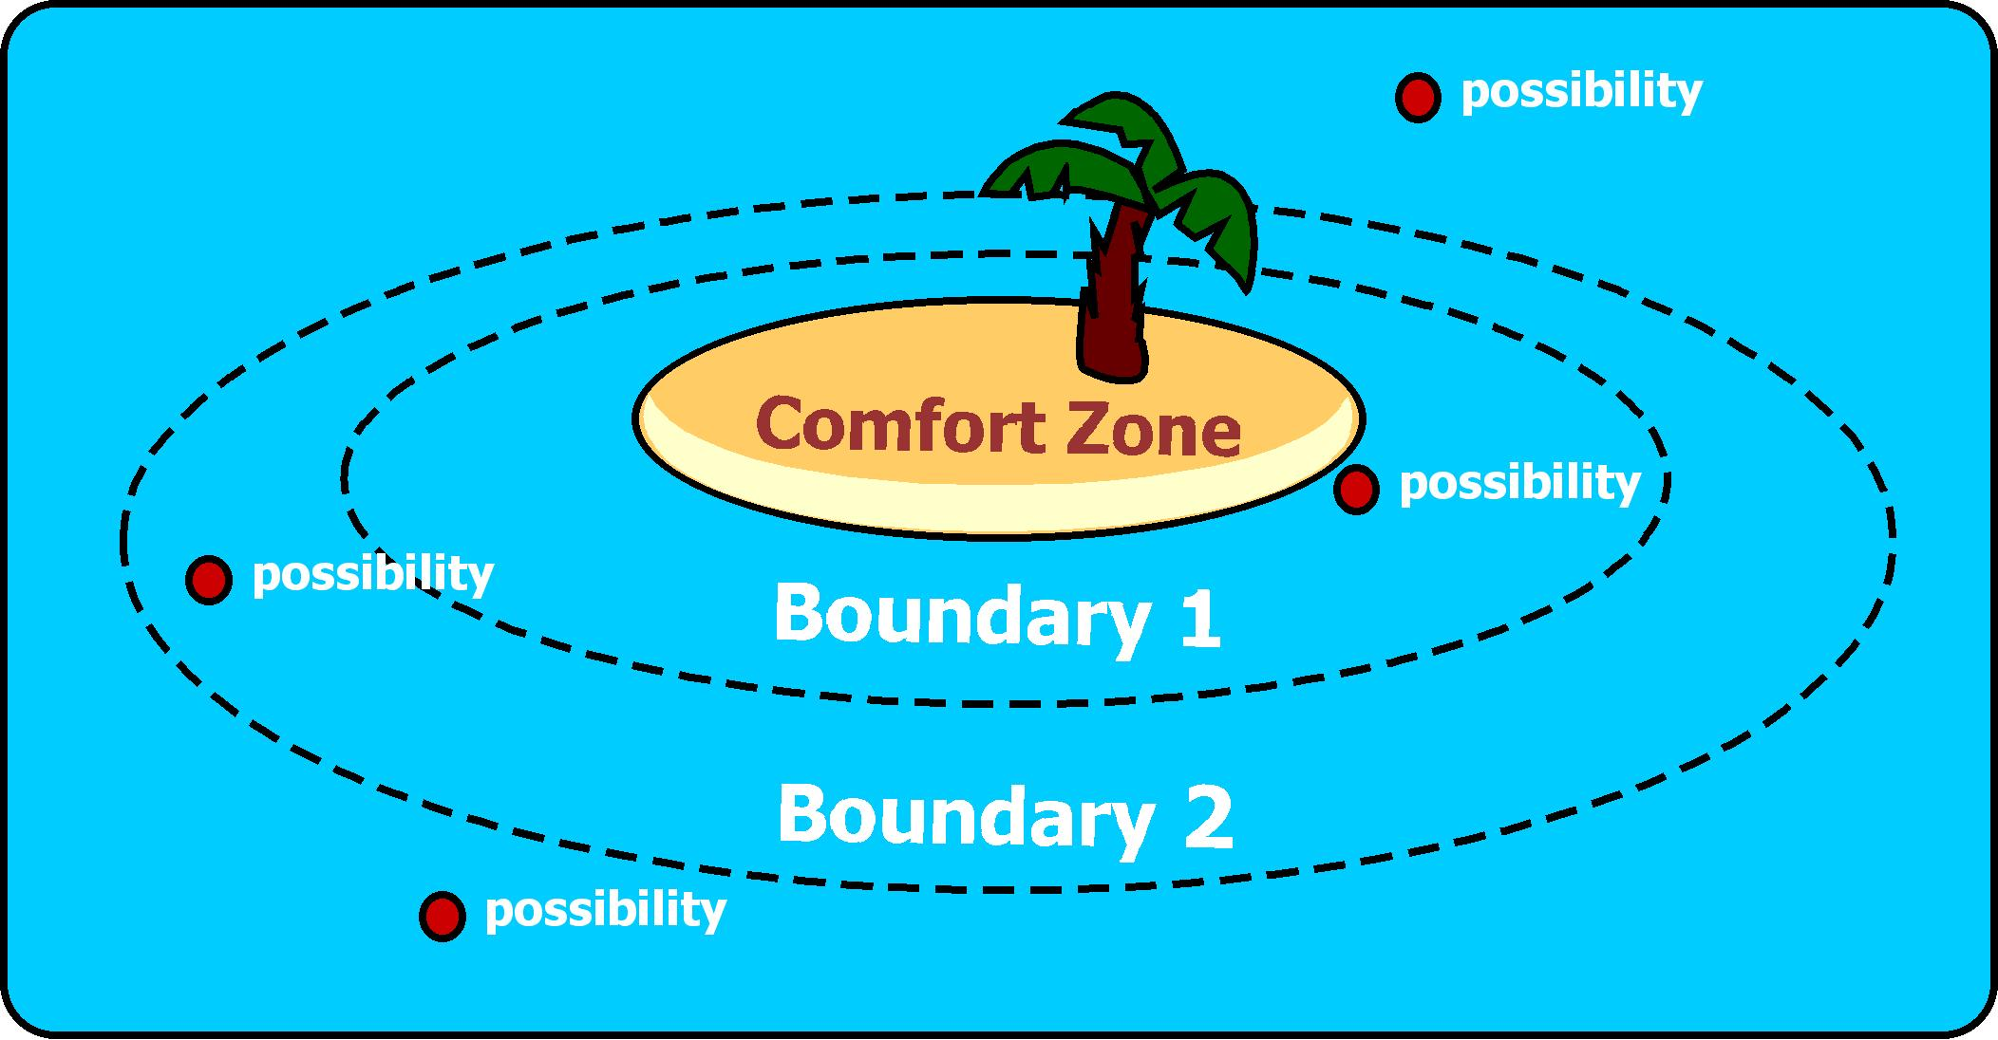People who stay within the same comfort zone for a long time usually become unhappy and feel like they are stagnating. This is often described as 'feeling stuck.'

People who are happy are those who try new things and are continually expanding their comfort zone.

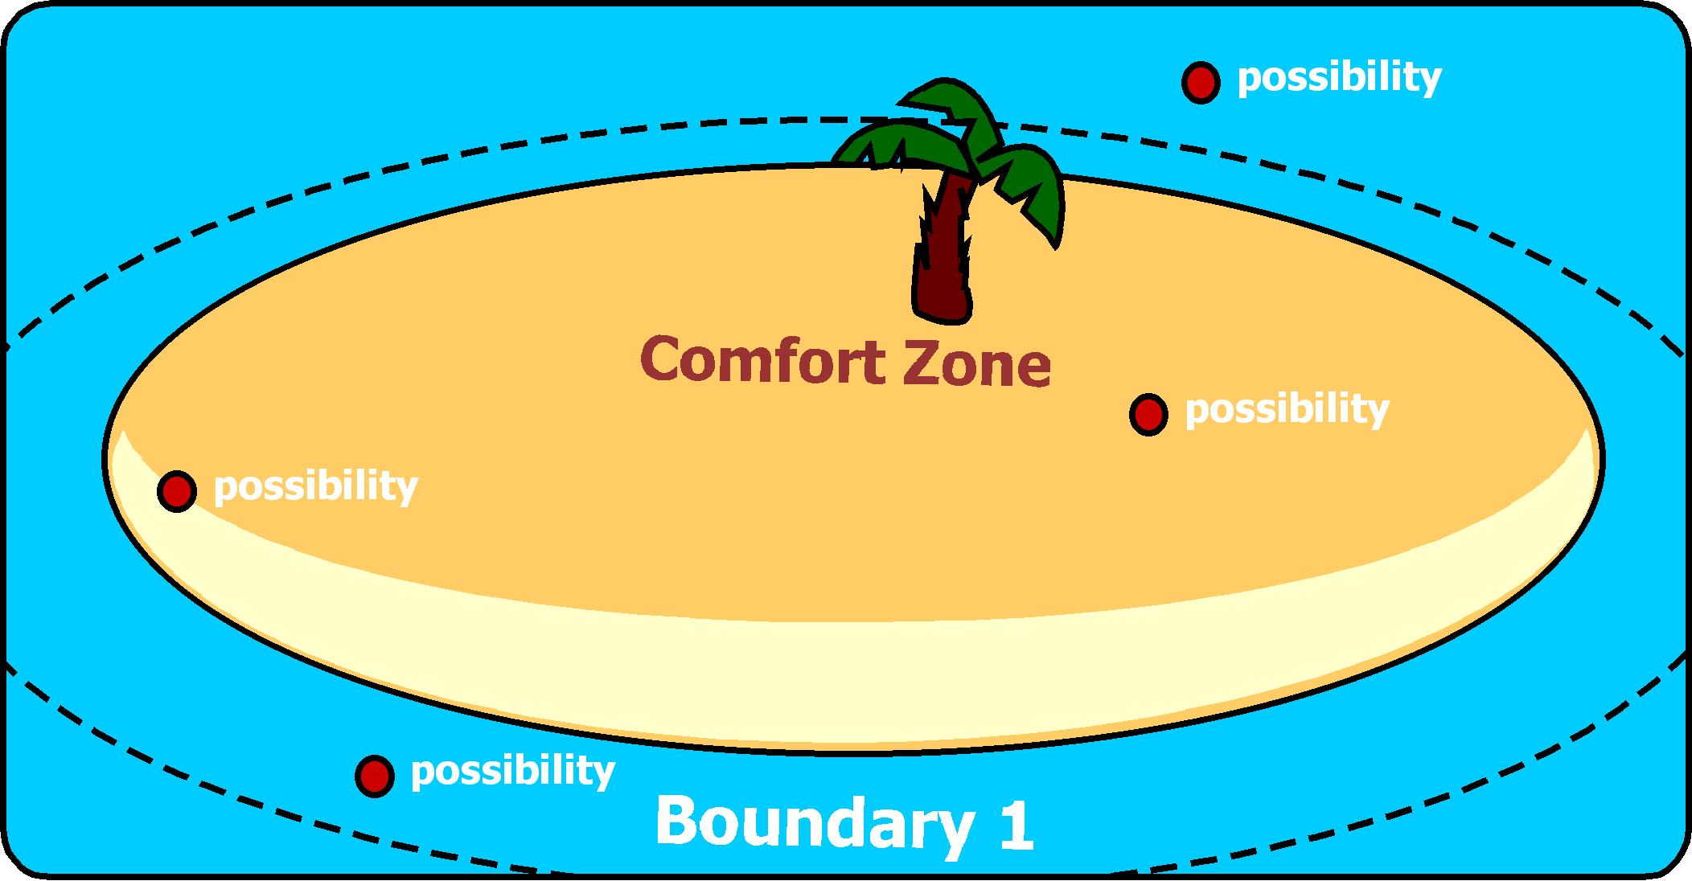

By continually expanding your comfort zone you are able to take on greater and greater possibilities and lead a more rich and fulfilling life.

To expand your comfort zone you need to take baby steps towards any goal or possibility that is outside your current comfort zone.

Once you have obtained the goal, your comfort zone will expand, making those possibilities that were once way outside your comfort zone now closer. Possibilities that once seemed impossible will now seem easier because you are different – by expanding your comfort zone you have gained new recourses. You will see the same possibilities with new eyes.

|  |
| --- |
| ***🖉 Draw a picture of your comfort zone and plot your goals/possibilities.*** |
|  |

|  |
| --- |
| ***🖉 What goal is the closest to your comfort zone and what steps will you take to   meet the goal?*** |
|  |
|  |
|  |
|  |
|  |
|  |
|  |
|  |
|  |
|  |
|  |
|  |
|  |

|  |
| --- |
| ***🖉 What goal is the farthest from your comfort zone and what steps will you take to   meet the goal?*** |
|  |
|  |
|  |
|  |
|  |
|  |
|  |
|  |
|  |
|  |
|  |
|  |
|  |

## SMART Goals

Having a goal is about having clarity about where you want to be in an area of your life. Goals provide direction and focus and, as you know, are necessary for continued lifelong learning and growth.

It is helpful to ensure that your goals are fit for purpose. The SMART model (below) outlines some simple guidelines that you can use for setting effective goals in the key areas of your life.

**S – Simple/Specific** Keep your goal simple and focused, rather than wordy and vague. Be very specific about the outcome you want.

**M – Measurable** How will you know when your goal has been reached? What will be different? How will you measure it?

**A – Attractive** Does this goal inspire you? Is it exciting enough to keep you enthusiastic in both the long and short term?

**R – Real** The goal must be achievable. Has someone done this before?

**T – Timed** State your goal as if it’s already been achieved. This trains the unconscious mind to accept the goal as real, which helps you to move more effectively towards it. Know by what date your goal will be realized.

|  |  |  |
| --- | --- | --- |
| **🖈** | ***EXAMPLE: SMART Goal***  *It is the morning of December 14, 2017 and I am standing on the scales in my bathroom and the dial is pointing to my ideal weight of 132lb/60kg.* |  |

|  |
| --- |
| **🖉 *Write one SMART goal for each area of your life.*** |
| Career/Business |
| Finances and Wealth |
| Friends and Family |
| Fun, Recreation and Entertainment |
| Health and Fitness |
| Love Life |
| Personal/Spiritual Development |
| Physical Environment |

## Accountability Partner(s)

Having an accountability partner is a great way to help boost your success.

Sometimes people feel OK when they let themselves down, but when there is someone else invested - they feel “on the hook”. You can find someone close to you, or find a likeminded individual by networking online. When you find someone you are comfortable with fill out the form below.

**My Accountability Partner(s) is**.........................................................................................

Reasons for Choice: ..............................................................................................................

............................................................................................................................................

............................................................................................................................................

.

I can help them by: ..............................................................................................................

............................................................................................................................................

............................................................................................................................................

They can help me by: ...........................................................................................................

............................................................................................................................................

............................................................................................................................................

I, ______________________ and my partner ______________________ will provide each

other accountability by agreeing to a quick chat on _________________ (day) of each week.

## Facing Fear

Fear is something everyone has to deal with. We may grow out of childhood fears but even as adults many of us are still afraid. We might be afraid of trying new things, public speaking, failure...and yes even success! Don’t be a slave to your fear. Face it. Your success depends on it.

“I *must not fear. Fear is the mind-killer. Fear is the little-death that brings total obliteration. I will face my fear... And when it is gone past I will turn the inner eye to see its path. Where the fear is gone there will be nothing. Only I will remain.” -* Frank Herbert

**Objective:** Do you want a GREAT tip? OK, let me ask you a question, "Why is facing fear just the opposite of building muscle?" Because the more you face your fears, the smaller they get. The more you work on building your muscles, the bigger they get."

Each time you face something that frightens you, it gets easier and easier. Fear will always be with all of us, but it becomes manageable with practice, and it becomes easier to do each time. It's when we don't face our fears that they become bigger and bigger until they overwhelm us or even paralyse us. A true and priceless tip, especially if you want to be successful!

This week we'll explore the nature of fear in general, your fears in particular, and techniques we can use to combat them.

**Facing Fear Exercises**

1. Make a list of your top ten fears.
2. Which of these fears are holding you back from your goals? List any of your fears that could impact your goals and state specifically how they can hinder your progress.
3. Choose one fear from above and write down a couple of ways you could “confront it”.
4. Confront that fear!

## Keeping Score

**Objective:** Small wins lead to big wins. That is the cycle of success. Far too often we strive for the big wins and don’t really take the time to appreciate the small victories along the way.

This might not seem like a big deal, but it isn’t great for your motivation. If you track your small wins, you will have one area where you can see and reflect on your successes with a glance. This will help keep you motivated, as well as potentially remind you of lessons learned along the way. This month is all about setting up and using a method to track your successes.

Keeping Score Exercises

1. Record all of your big and small wins/successes this week.
2. List the 10 greatest wins/successes in your life and write in detail about what made them great.
3. List what you learned from your greatest wins/successes.