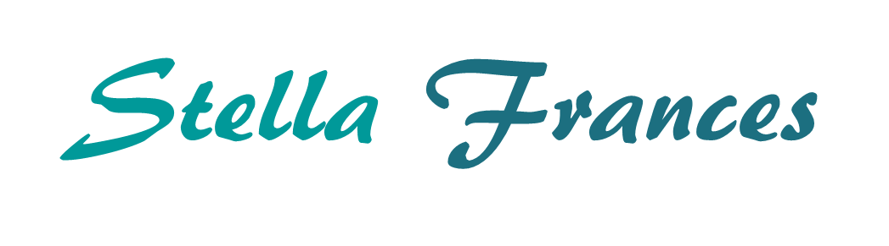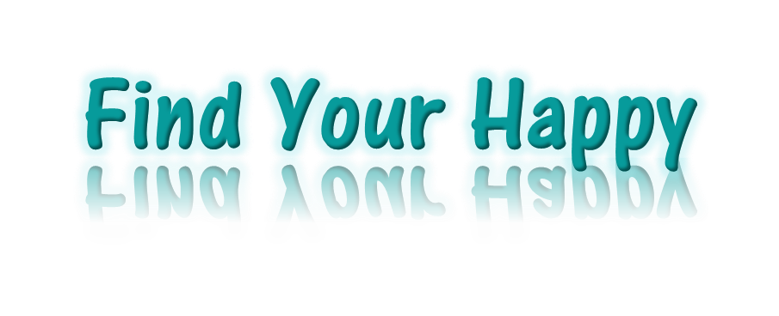

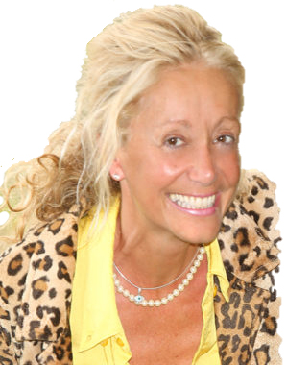

**BELIEFS**

**Exploring Beliefs**

**Defining Moments**

***“The outer conditions of a person's life will always be found to reflect their inner beliefs”  
 James Allen***

**COMPLETED BY: ........................................................................**

**DATE: ...........................................................................................**

# The Find Your Happy Framework

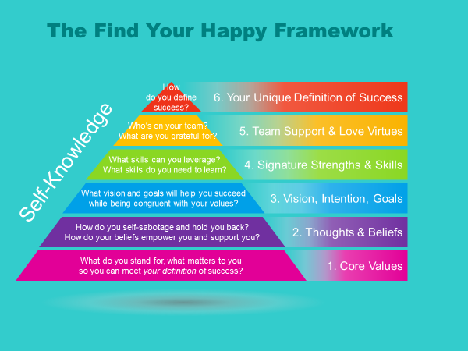

The Find Your Happy program will assist you to open up the way you think about yourself, the way you think about the world and set the stage for new beginnings and personal success.

# Beliefs

Hello and welcome back! The next layer in the Find Your Happy program is beliefs. Simply stated, beliefs are a feeling of certainty around what a thing means.

Like values, your beliefs motivate you and impact your results. You collect your beliefs, usually subconsciously, from your friends, family and society, and from your experiences. It is usually easier to radically change a belief than it is to radically change a value, because beliefs come from interpreting an event at a specific point in time.

|  |  |  |
| --- | --- | --- |
| **🖈** | ***EXAMPLE: Changing Values versus Changing Beliefs***  *It is harder to go from valuing 'health' to valuing 'illness,' and easier to go from believing that you are 'unfit' to believing that you are 'healthy.'* |  |

Beliefs can be totally empowering or totally disempowering (see example below). Most people are carrying around many disempowering beliefs that bring them down every day and they don’t even know it…

|  |  |  |  |
| --- | --- | --- | --- |
| **🖈** | ***EXAMPLE:***  ***Disempowering Belief*** | ***Empowering Belief*** |  |
|  | *I will never get ahead*  *I always mess things up* | *I always learn something when I try something new* |  |

How many disempowering and empowering beliefs are you carrying around with you? Let’s take a look at your beliefs and make sure that they all serve, support, nurture and challenge you.

|  |  |
| --- | --- |
| Image result for starImage result for star | *“Whether you think you can or whether you think you can’t, you are right.”*  ***Henry Ford*** |

## Exploring Beliefs

Explore some of your beliefs by completing the following sentences.

*Note: 'They' could represent your family, work colleagues or friends. 'She/He' could represent someone who is important to you like you mother/father, daughter/son, sister/brother, friend, etc.*

| ***🖉 My beliefs:*** |
| --- |
| I always… |
| I never… |
| They are… |
| I can’t… |
| We are… |
| I must… |
| I must… |
| My work is… |
| My time is… |
| My team is… |
| There are times when I… |
| Life is all about… |
| I love… |
| Success is… |
| Teamwork is… |
| Life is… |
| Family is… |
| Love is… |
| She can… |
| She is… |
| My parents are… |
| He could… |
| He is… |
| I am… |
| They are… |
| I can… |
| I can… |
| I can… |

|  |  |
| --- | --- |
| **🛠** | ***Empowering or Disempowering?***  Take a few minutes to review your responses to each of the previous phrases. Write a 'D' next to each belief that is disempowering and an 'E' next to each belief that is empowering. |

|  |
| --- |
| **🖉 *What does the previous exercise tell you about your beliefs?*** |
|  |
|  |
|  |
|  |
|  |
|  |
|  |
|  |
|  |
|  |

|  |
| --- |
| **🖉 *What empowering beliefs do you have?*** |
|  |
|  |
|  |
|  |
|  |
|  |
|  |
|  |
|  |
|  |
|  |

|  |
| --- |
| **🖉 *What can you replace your disempowering beliefs with?*** |
|  |
|  |
|  |
|  |
|  |
|  |
|  |
|  |
|  |
|  |
|  |

## Defining Moments

A defining moment is an important past event, often experienced when you were a child. What makes the event important is not the intensity, greatness or the significance of the event itself, but the importance you have given it by unconsciously forming a lifelong belief or set of beliefs around the event.

Most of adults have five to eight defining moments.

|  |  |  |
| --- | --- | --- |
| **🖈** | ***EXAMPLE: Defining Moments***   * *Sarah’s partner got very drunk at their wedding and she formed the belief that her husband will always let her down at important events.* * *John’s mom was very angry with him when he was 10 and she told him he was stupid. Although she didn’t really mean it, John formed the belief that will never be enough for his mother.* * *Sam fell off a horse when she was little and broke her leg. She formed the belief that anything that is fun is dangerous.* * *James was told that he was a great artist by his teacher in second grade. He decided that he was artistic from then on.* |  |

Once you have formed a belief from a defining moment, you hold on to it and search for evidence to strengthen the belief. If you have created an empowering belief (as in the case of James in the example above), this is great, but if you have latched onto a disempowering belief (like Sarah, John and Sam) you are in real trouble because over the years you build up so much evidence to support the belief that it becomes ingrained in you and you don’t even think to question it as an adult.

The good news is that you can let disempowering beliefs go if you want to, and this section shows you how to do just that.

1. Discover your defining moments.
2. Open them up and look at the beliefs you created from these moments.
3. Decide which beliefs you want to keep, enhance or delete.

You can’t change the past but you can change your interpretation of the past, and you can reshape your beliefs to serve, support, nurture and challenge you if you choose to.

List five to eight defining moments from your childhood.

|  |
| --- |
| ***🖉 Your defining moments:*** |
| 1. |
|  |
| 2. |
|  |
| 3. |
|  |
| 4. |
|  |
| 5. |
|  |
| 6. |
|  |
| 7.  . |
|  |
| 8. |
|  |

|  |  |
| --- | --- |
| Image result for starImage result for star | *“You can’t change the past but you can change your interpretation of the past.”* |

|  |
| --- |
| ***🖉 Answer the following questions for one of your defining moments.*** |
| **My defining moment was:** |
| How old were you? |
|  |
| What happened, who was there, and what was said? |
|  |
|  |
|  |
|  |
| What did you tell yourself then? |
|  |
|  |
|  |
|  |
| What belief(s) have you carried forward since then? |
|  |
|  |
|  |
|  |
|  |
| What would you have wanted to happen? |
|  |
|  |
|  |
|  |
|  |
| What belief(s) do you want to keep? |
|  |
|  |
|  |
|  |
| What belief(s) do you want to change and what will you change it to? |
|  |
|  |
|  |
| What will you be giving up if you don’t create the change? |
|  |
|  |
|  |
|  |
| What is one thing you can do to reinforce the new belief(s) on a daily basis? |
|  |
|  |
|  |
|  |

|  |
| --- |
| ***🖉 Answer the following questions for one of your defining moments.*** |
| **My defining moment was:** |
| How old were you? |
|  |
| What happened, who was there, and what was said? |
|  |
|  |
|  |
|  |
|  |
| What did you tell yourself then? |
|  |
|  |
|  |
|  |
| What belief(s) have you carried forward since then? |
|  |
|  |
|  |
|  |
|  |
| What would you have wanted to happen? |
|  |
|  |
|  |
|  |
| What belief(s) do you want to keep? |
|  |
|  |
|  |
|  |
| What belief(s) do you want to change and what will you change it to? |
|  |
|  |
|  |
| What will you be giving up if you don’t create the change? |
|  |
|  |
|  |
|  |
| What is one thing you can do to reinforce the new belief(s) on a daily basis? |
|  |
|  |
|  |
|  |

|  |
| --- |
| ***🖉 Answer the following questions for one of your defining moments.*** |
| **My defining moment was:** |
| How old were you? |
|  |
| What happened, who was there, and what was said? |
|  |
|  |
|  |
|  |
|  |
| What did you tell yourself then? |
|  |
|  |
|  |
|  |
| What belief(s) have you carried forward since then? |
|  |
|  |
|  |
|  |
|  |
| What would you have wanted to happen? |
|  |
|  |
|  |
|  |
| What belief(s) do you want to keep? |
|  |
|  |
|  |
|  |
| What belief(s) do you want to change and what will you change it to? |
|  |
|  |
|  |
| What will you be giving up if you don’t create the change? |
|  |
|  |
|  |
|  |
| What is one thing you can do to reinforce the new belief(s) on a daily basis? |
|  |
|  |
|  |
|  |